Database Basics MS SQL Exam – 27 June 2020
Database Fundamentals MSSQL – Washing Machine Service
Your task is to implement Washing Machine Service database based on the specs given below. Database will include information about broken machines which will be distributed to mechanics through so called “jobs”. Each mechanic may have several jobs and for each job he/she can require some parts. To let the mechanic get whats needed he/she has to make order for a particular part also specifying how many of it will be needed (specifying quantity).

Section 1. DDL
You have been given the E/R Diagram of the washing machine service:
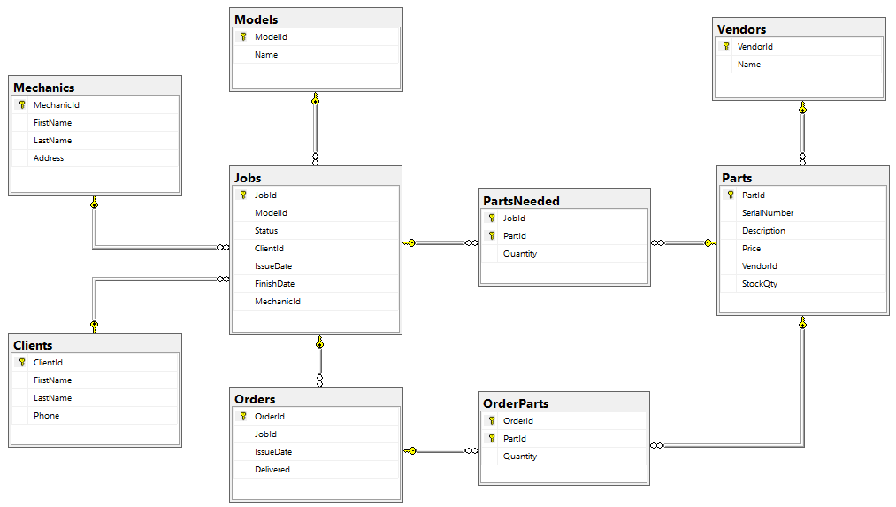
Crate a database called WMS. You need to create 9 tables:
- Clients – contains information about the customers that use the service
- Mechanics – contains information about employees
- Jobs – contains information about all machines that clients submitted for repairs
- Models – list of all washing machine models that the servie operates with
- Orders – contains information about orders for parts
- Parts – list of all parts the service operates with
- OrderParts – mapping table between Orders and Parts with additional Quantity field
- PartsNeeded – mapping table between Jobs and Parts with additional Quantity field
- Vendors – list of vendors that supply parts to the service
Include the following fields in each table. Unless otherwise specified, all fields are required.
Clients
Column Name | Data Type | Constraints
ClientId | 32-bit Integer | Primary table identificator, Identity
FirstName | String up to 50 symbols, ASCII
LastName | String up to 50 symbols, ASCII
Phone | String containing 12 symbols | String length is exactly 12 chars long

Mechanics
Column Name | Data Type | Constraints
MechanicId | 32-bit Integer | Primary table identificator, Identity
FirstName | String up to 50 symbols, ASCII
LastName | String up to 50 symbols, ASCII
Address | String up to 255 symbols, ASCII

Jobs
Column Name | Data Type | Constraints
JobId | 32-bit Integer | Primary table identificator, Identity
ModelId | 32-bit Integer | Relationship with table Models
Status | String up to 11 symbols, ASCII | Allowed values: 'Pending', 'In Progress' and 'Finished'; Default value is 'Pending'
ClientId | 32-bit Integer | Relationship with table Clients
MechanicId | 32-bit Integer | Relationship with table Mechanics; Can be NULL
IssueDate | Date
FinishDate | Date | Can be NULL

Models
Column Name | Data Type | Constraints
ModelId | 32-bit Integer | Primary table identificator, Identity
Name | String up to 50 symbols, ASCII | Unique

Orders
Column Name | Data Type | Constraints
OrderId | 32-bit Integer | Primary table identificator, Identity
JobId | 32-bit Integer | Relationship with table Jobs
IssueDate | Date | Can be NULL
Delivered | Boolean | Default value is False

Parts
Column Name | Data Type | Constraints
PartId | 32-bit Integer | Primary table identificator, Identity
SerialNumber | String up to 50 symbols, ASCII | Unique
Description | String up to 255 symbols, ASCII | Can be NULL
Price | Monetary value up to 9999.99 | Cannot be zero or negative
VendorId | 32-bit Integer | Relationship with table Vendors
StockQty | 32-bit Integer | Cannot be negative; Default value is 0

OrderParts
Column Name | Data Type | Constraints
OrderId | 32-bit Integer | Relationship with table Orders;  Primary table identificator
PartId | 32-bit Integer | Relationship with table Parts;  Primary table identificator
Quantity | 32-bit Integer | Cannot be zero or negative; Default value is 1

PartsNeeded
Column Name | Data Type | Constraints
JobId | 32-bit Integer | Relationship with table Jobs;  Primary table identificator
PartId | 32-bit Integer | Relationship with table Parts;  Primary table identificator
Quantity | 32-bit Integer | Cannot be zero or negative; Default value is 1

Vendors
Column Name | Data Type | Constraints
VendorId | 32-bit Integer | Primary table identificator, Identity
Name | String up to 50 symbols, ASCII | Unique

Database design
Submit all of your create statements to Judge. Do not include database creation statements.
Look for hints in the details of your submission!

Section 2. DML
Before you start you have to import Data.sql. If you have created the structure correctly the data should be successfully inserted.
In this section, you have to do some data manipulations:

Insert
Let’s insert some sample data into the database. Write a query to add the following records into the corresponding tables. All Id’s should be auto-generated. Replace names that relate to other tables with the appropriate ID (look them up manually, there is no need to perform table joins).
Clients
First Name | Last Name | Phone
Teri | Ennaco | 570-889-5187
Merlyn | Lawler | 201-588-7810
Georgene | Montezuma | 925-615-5185
Jettie | Mconnell | 908-802-3564
Lemuel | Latzke | 631-748-6479
Melodie | Knipp | 805-690-1682
Candida | Corbley | 908-275-8357

Parts
Serial Number | Description | Price | VendorId
WP8182119 | Door Boot Seal | 117.86 | 2
W10780048 | Suspension Rod | 42.81 | 1
W10841140 | Silicone Adhesive | 6.77 | 4
WPY055980 | High Temperature Adhesive | 13.94 | 3

Update
Assign all Pending jobs to the mechanic Ryan Harnos (look up his ID manually, there is no need to use table joins) and change their status to 'In Progress'.

Delete
Cancel Order with ID 19 – delete the order from the database and all associated entries from the mapping table.

Section 3. Querying
You need to start with a fresh dataset, so run the Data.sql script again. It includes a section that will delete all records and replace them with the starting set, so you don’t need to drop your database.

Mechanic Assignments
Select all mechanics with their jobs. Include job status and issue date. Order by mechanic Id, issue date, job Id (all ascending).
Required columns:
- Mechanic Full Name
- Job Status
- Job Issue Date
Example:
Mechanic | Status | IssueDate
Joni Breland | Finished | 2017-01-12
Joni Breland | Finished | 2017-01-17
Joni Breland | Finished | 2017-01-24
… | … | …

Current Clients
Select the names of all clients with active jobs (not Finished). Include the status of the job and how many days it’s been since it was submitted. Assume the current date is 24 April 2017. Order results by time length (descending) and by client ID (ascending).
Required columns:
- Client Full Name
- Days going – how many days have passed since the issuing
- Status
Example:
Client | Days going | Status
Gertude Witten | 18 | In Progress
Brittni Gillaspie | 14 | In Progress
Levi Munis | 12 | In Progress
… | … | …

Mechanic Performance
Select all mechanics and the average time they take to finish their assigned jobs. Calculate the average as an integer. Order results by mechanic ID (ascending).
Required columns:
- Mechanic Full Name
- Average Days – average number of days the machanic took to finish the job
Example:
Mechanic | Average Days
Joni Breland | 9
Malcolm Tromblay | 10
Ryan Harnos | 5
… | …

Available Mechanics
Select all mechanics without active jobs (include mechanics which don’t have any job assigned or all of their jobs are finished). Order by ID (ascending).
Required columns:
- Mechanic Full Name
Example:
Available
Joni Breland
Ryan Harnos
…

Past Expenses
Select all finished jobs and the total cost of all parts that were ordered for them. Sort by total cost of parts ordered (descending) and by job ID (ascending).
Required columns:
- Job ID
- Total Parts Cost
Example:
JobId | Total
17 | 173.60
12 | 140.50
1 | 91.86
… | …

Missing Parts
List all parts that are needed for active jobs (not Finished) without sufficient quantity in stock and in pending orders (the sum of parts in stock and parts ordered is less than the required quantity). Order them by part ID (ascending).
Required columns:
- Part ID
- Description
- Required – number of parts required for active jobs
- In Stock – how many of the part are currently in stock
- Ordered – how many of the parts are expected to be delivered (associated with order that is not Delivered)
Example:
PartId | Description | Required | In Stock | Ordered
12 | Shock Dampener | 2 | 1 | 0
14 | Door Handle | 1 | 0 | 0
17 | Lid Switch Assembly | 1 | 0 | 0

Section 4. Programmability

Place Order
Your task is to create a user defined procedure (usp_PlaceOrder) which accepts job ID, part serial number and quantity and creates an order with the specified parameters. If an order already exists for the given job that and the order is not issued (order’s issue date is NULL), add the new product to it. If the part is already listed in the order, add the quantity to the existing one.
When a new order is created, set it’s IssueDate to NULL.
Limitations:
- An order cannot be placed for a job that is Finished; error message ID 50011 "This job is not active!"
- The quantity cannot be zero or negative; error message ID 50012 "Part quantity must be more than zero!"
- The job with given ID must exist in the database; error message ID 50013 "Job not found!"
- The part with given serial number must exist in the database ID 50014 "Part not found!"
If any of the requirements aren’t met, rollback any changes to the database you’ve made and throw an exception with the appropriate message and state 1.
Parameters:
- JobId
- Part Serial Number
- Quantity
Example usage:
Query
DECLARE @err_msg AS NVARCHAR(MAX);
BEGIN TRY
EXEC usp_PlaceOrder 1, 'ZeroQuantity', 0
END TRY

BEGIN CATCH
SET @err_msg = ERROR_MESSAGE();
SELECT @err_msg
END CATCH
Response
Part quantity must be more than zero!

Cost Of Order
Create a user defined function (udf_GetCost) that receives a job’s ID and returns the total cost of all parts that were ordered for it. Return 0 if there are no orders.
Parameters:
- JobId
Example usage:
Query
SELECT dbo.udf_GetCost(1)
Id | Result
1 | 91.86
3 | 40.97
… | …

